**White Hat Hackers**

**Key Contributors: Joshua Mata, Everett Getchell**

**Nate Otting**

**University of the Incarnate Word**

**2/1/24**

This project and the preparation of this report were funded in part by ….through an agreement with the University of the Incarnate Word.

Cyber Security Systems and the University of the Incarnate Word

# EXECUTIVE SUMMARY

Start of executive summary ……

Project Milestones: E.g. Major steps required to complete your project.

1. Milestone 1 description
2. Milestone 2 description
3. Milestone 3 description

Materials List:

1. Item 1 (Qty: #)
2. Item 2 (Qty: #)
3. Item 3 (Qty: #)

Deliverables: E.g. Report, Deployed architecture, other project outcomes etc.

1. Deliverable 1
2. Deliverable 2
3. Deliverable 3

Professional Accomplishments: E.g. New skills that you developed

1. Accomplishment 1
2. Accomplishment 2
3. Accomplishment 3

# PROJECT SCHEDULE MANAGEMENT

Create a Gantt chart with the application of your choice and replace it with the picture presented below.

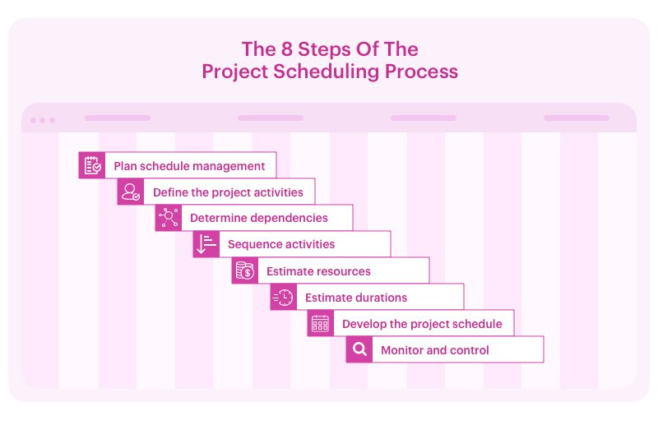

Project Management Board Link (QR Code Only). Send invite to user: @gdparra

Create a Github Project Repository and add the user “cyberknowledge” as a contributor.

https://github.com/your_username/your_project_repo_name

# TABLE OF CONTENTS

[List]

[SECTION HEADER]

[HEADER 1**]**

[Body Text]

[Header 2]

[Body Text]

[Header 3]

[Body Text]



***Significant takeaways / Boxed text***

**TITLE PAGE TITLE** (Calibri, 20 R: 0 G: 32 B: 96)

**Authors / Contributors** (Calibri, 20, RGB Hex: cb333b)(Logos can be used)   
**Date** (Calibri, 20, RGB Hex: cb333b)

This project and the preparation of this report were funded in part by monies provided by CPS Energy through an agreement with The University of Texas at San Antonio.

©CPS Energy and the University of Texas at San Antonio

**-----------------------------------------------------------------------------------------------------------------------------**

**EXECUTIVE SUMMARY**(Cambria, 15.5 RGB Hex: 003960)

TEXT (Cambria, 12 Black)

Sub-Text (Calibri, 9.5 Black)

**TABLE OF CONTENTS** (Cambria, 15.5 RGB Hex: 003960

TEXT (Cambria, 12 Black)

Sub-Text (Calibri, 9.5 Black)

**-----------------------------------------------------------------------------------------------------------------------------**

SECTION HEADER

(SECTION HEADER: Cambria, 26 RGB Hex: 003960)

**HEADER 1** (Cambria, 15.5 RGB Hex: 003960)

**Header 2** (Cambria, 14 RGB Hex: 005a98)

Header 3 (Cambria, 13 RGB Hex: cb333b)

Body Text (Calibri, 10.5 Black)

***Boxed Text*** (Calibri, 9.5 Black Bold Italics)

*Letter of Transmittal Sample*

November 23,2021

University of The Incarnate Word

Attention: Dr. Gonzalo. D. Parra

4301 Broadway

San Antonio, TX 78209

Dear Dr. Parra:

With this letter, the team ____________ transmits the following items associated with the **CIS 3353 Final Project**.

**SCOPE OF WORK (dated 11/23/2021): “Title of Your Work”**

* DELIVERABLES related to the _______ sub-task:

Aim 1:

Deliverable 1

Deliverable 2

Aim 2:

Deliverable 1

Deliverable 2

Please share these with your team as appropriate. If you have any questions, please contact ________ at (210) 458-8618 or by email at _________.

Kindest regards,

Team Lead  
Student of Cyber Security Systems at the University of the Incarnate Word